|  | **cOurse syllabus template**  8 October 2024 |
| --- | --- |

Please read and follow the [instructions for course syllabuses](https://internt.slu.se/globalassets/mw/org-styr/styr-dok/3-utbildning-grund-avancerad-forsk/anvisningar-kursplaner-en.pdf) before filling in the template. Fields marked * are compulsory. Select an option from the drop-down list, or type under the heading. Some of the headings are accompanied by a text box with notes such as this one. The course syllabus also contains some standardised text that will be automatically displayed in a red box on the course page. They are only included to show the final layout on the course page. *Do not enter this text into the template* manually, otherwise it will be entered into Ladok and displayed twice. SLU is a public authority and Swedish is its official language. Course syllabuses are a legally binding document and must therefore be written in Swedish. SLU rules stipulate that an English translation of a course syllabus is to be made available, although this version is not legally binding. See pages 2 and 3 of the [instructions](https://internt.slu.se/globalassets/mw/org-styr/styr-dok/3-utbildning-grund-avancerad-forsk/anvisningar-kursplaner-en.pdf). Course syllabus templates are available in Swedish and English. The free-text fields in the Swedish version include bilingual headings to facilitate translation. The English template is monolingual.

**Swedish course name\*** *(Max. 100 characters)*

**English course name* *(****Max. 100 characters)*

**Course scope (credits)\***

**Responsible department\***

Select a department.

**Valid from\***

Select a semester.

**Grading scale\***

Select an option.



**Main field of study/subject**\*

You must choose **either** a main field of study **or** a subject. An additional main field of study or subject may be included for courses with a double classification. The level (cycle) and specialisation must be stated for main fields of study. See page 5 of the [instructions](https://internt.slu.se/globalassets/mw/org-styr/styr-dok/3-utbildning-grund-avancerad-forsk/anvisningar-kursplaner-en.pdf).

**Main field of study:**  Select main field of study

**Additional main field, if applicable:** Select main field of study

**Level and specialisation:** Select level and specialisation.

**Subject:**  Select a subject.

A specialisation or sub-area must be stated below if biology and forestry science are the main fields of study. See [Subject descriptions](https://student.slu.se/globalassets/mw/stod-serv/utbildning/grund--och-avancerad-niva/utbildningshandbok/annex-3b-main-fields-of-study.pdf), and page 6 of the [instructions](https://internt.slu.se/globalassets/mw/org-styr/styr-dok/3-utbildning-grund-avancerad-forsk/anvisningar-kursplaner-en.pdf).

**Biology specialisation, if applicable**

Select a biology specialisation.

**Forestry science sub-area, if applicable**

**Language of instruction\***

Select language.

See pages 7 and 13 of the [instructions](https://internt.slu.se/globalassets/mw/org-styr/styr-dok/3-utbildning-grund-avancerad-forsk/anvisningar-kursplaner-en.pdf), for examples of how to formulate requirements.

**Entry requirements\***

You can write a brief description of the purpose of the course under before stating the set learning objectives as bullet points. See page 9 of the [instructions](https://internt.slu.se/globalassets/mw/org-styr/styr-dok/3-utbildning-grund-avancerad-forsk/anvisningar-kursplaner-en.pdf).

**Objectives\***

Upon successful completion of the course, students will be able to:

Briefly describe the course content, regarding both subject-related content and teaching formats. See pages 10 and 16 of the [instructions](https://internt.slu.se/globalassets/mw/org-styr/styr-dok/3-utbildning-grund-avancerad-forsk/anvisningar-kursplaner-en.pdf).

**Content\***

*Subject-related content*

*Teaching formats*

To further student learning and promote discussion, a variety of methods are used, such as:

The course focuses on the following generic skills:

Collaboration with the surrounding community takes place through:

State how the assessments will take place and any other conditions for passing the course (e.g., passing compulsory components). See pages 10 and 17 of the [instructions](https://internt.slu.se/globalassets/mw/org-styr/styr-dok/3-utbildning-grund-avancerad-forsk/anvisningar-kursplaner-en.pdf).

**Examination formats**

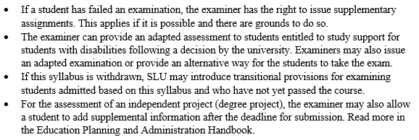

The course webpage contains important information that is not formally included in the course syllabus. See page 11 of the [instructions](https://internt.slu.se/globalassets/mw/org-styr/styr-dok/3-utbildning-grund-avancerad-forsk/anvisningar-kursplaner-en.pdf).

## Supplementary course information

**Jointly responsible department(s), if applicable**

**Replaces** *(Course code(s) partly or entirely replaced by this course)*

**Additional information**

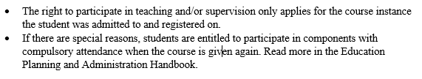

Course syllabus written by*(Name and email address)*